## Junit测试问题

配置：

<dependency>  
 <groupId>junit</groupId>  
 <artifactId>junit</artifactId>  
 <version>4.12</version>  
 <scope>test</scope>  
</dependency>

<dependency>  
 <groupId>org.springframework</groupId>  
 <artifactId>spring-test</artifactId>  
 <version>3.1.1.RELEASE</version>  
</dependency>

Spring3.1+Jdk1.7

虽然错误都已经标出来的，但是值得怀疑的地方只有一个读取Junit5的地方。

最后只能升级到spring4.3.14，jdk换成1.8，其实1.7下面这个测试也可以通过，但是不知道其他地方会不会出错

测试代码：

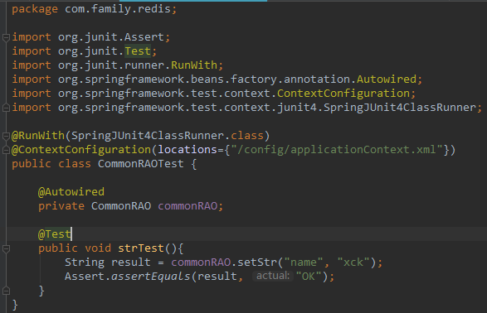

错误信息：

十一月 07, 2018 9:07:09 上午 org.springframework.test.context.TestContextManager retrieveTestExecutionListeners

信息: @TestExecutionListeners is not present for class [class com.family.redis.CommonRAOTest]: using defaults.

十一月 07, 2018 9:07:09 上午 org.springframework.beans.factory.xml.XmlBeanDefinitionReader loadBeanDefinitions

信息: Loading XML bean definitions from class path resource [config/applicationContext.xml]

十一月 07, 2018 9:07:10 上午 org.springframework.test.context.TestContextManager prepareTestInstance

严重: Caught exception while allowing TestExecutionListener [org.springframework.test.context.support.DependencyInjectionTestExecutionListener@75724060] to prepare test instance [com.family.redis.CommonRAOTest@1fe09add]

java.lang.IllegalStateException: Failed to load ApplicationContext

at org.springframework.test.context.TestContext.getApplicationContext(TestContext.java:157)

at org.springframework.test.context.support.DependencyInjectionTestExecutionListener.injectDependencies(DependencyInjectionTestExecutionListener.java:109)

at org.springframework.test.context.support.DependencyInjectionTestExecutionListener.prepareTestInstance(DependencyInjectionTestExecutionListener.java:75)

at org.springframework.test.context.TestContextManager.prepareTestInstance(TestContextManager.java:321)

at org.springframework.test.context.junit4.SpringJUnit4ClassRunner.createTest(SpringJUnit4ClassRunner.java:211)

at org.springframework.test.context.junit4.SpringJUnit4ClassRunner$1.runReflectiveCall(SpringJUnit4ClassRunner.java:288)

at org.junit.internal.runners.model.ReflectiveCallable.run(ReflectiveCallable.java:12)

at org.springframework.test.context.junit4.SpringJUnit4ClassRunner.methodBlock(SpringJUnit4ClassRunner.java:290)

at org.springframework.test.context.junit4.SpringJUnit4ClassRunner.runChild(SpringJUnit4ClassRunner.java:231)

at org.junit.runners.BlockJUnit4ClassRunner.runChild(BlockJUnit4ClassRunner.java:57)

at org.junit.runners.ParentRunner$3.run(ParentRunner.java:290)

at org.junit.runners.ParentRunner$1.schedule(ParentRunner.java:71)

at org.junit.runners.ParentRunner.runChildren(ParentRunner.java:288)

at org.junit.runners.ParentRunner.access$000(ParentRunner.java:58)

at org.junit.runners.ParentRunner$2.evaluate(ParentRunner.java:268)

at org.springframework.test.context.junit4.statements.RunBeforeTestClassCallbacks.evaluate(RunBeforeTestClassCallbacks.java:61)

at org.springframework.test.context.junit4.statements.RunAfterTestClassCallbacks.evaluate(RunAfterTestClassCallbacks.java:71)

at org.junit.runners.ParentRunner.run(ParentRunner.java:363)

at org.springframework.test.context.junit4.SpringJUnit4ClassRunner.run(SpringJUnit4ClassRunner.java:174)

at org.junit.runner.JUnitCore.run(JUnitCore.java:137)

at com.intellij.junit4.JUnit4IdeaTestRunner.startRunnerWithArgs(JUnit4IdeaTestRunner.java:68)

at com.intellij.rt.execution.junit.IdeaTestRunner$Repeater.startRunnerWithArgs(IdeaTestRunner.java:47)

at com.intellij.rt.execution.junit.JUnitStarter.prepareStreamsAndStart(JUnitStarter.java:242)

at com.intellij.rt.execution.junit.JUnitStarter.main(JUnitStarter.java:70)

Caused by: org.springframework.beans.factory.BeanDefinitionStoreException: Failed to read candidate component class: URL [jar:file:/D:/xck/editor/IntelliJ%20IDEA%202018.1.5/plugins/junit/lib/junit5-rt.jar!/com/intellij/junit5/JUnit5IdeaTestRunner.class]; nested exception is java.lang.ArrayIndexOutOfBoundsException: 7663

at org.springframework.context.annotation.ClassPathScanningCandidateComponentProvider.findCandidateComponents(ClassPathScanningCandidateComponentProvider.java:261)

at org.springframework.context.annotation.ClassPathBeanDefinitionScanner.doScan(ClassPathBeanDefinitionScanner.java:242)

at org.springframework.context.annotation.ComponentScanBeanDefinitionParser.parse(ComponentScanBeanDefinitionParser.java:84)

at org.springframework.beans.factory.xml.NamespaceHandlerSupport.parse(NamespaceHandlerSupport.java:73)

at org.springframework.beans.factory.xml.BeanDefinitionParserDelegate.parseCustomElement(BeanDefinitionParserDelegate.java:1419)

at org.springframework.beans.factory.xml.BeanDefinitionParserDelegate.parseCustomElement(BeanDefinitionParserDelegate.java:1409)

at org.springframework.beans.factory.xml.DefaultBeanDefinitionDocumentReader.parseBeanDefinitions(DefaultBeanDefinitionDocumentReader.java:184)

at org.springframework.beans.factory.xml.DefaultBeanDefinitionDocumentReader.doRegisterBeanDefinitions(DefaultBeanDefinitionDocumentReader.java:140)

at org.springframework.beans.factory.xml.DefaultBeanDefinitionDocumentReader.registerBeanDefinitions(DefaultBeanDefinitionDocumentReader.java:111)

at org.springframework.beans.factory.xml.XmlBeanDefinitionReader.registerBeanDefinitions(XmlBeanDefinitionReader.java:493)

at org.springframework.beans.factory.xml.XmlBeanDefinitionReader.doLoadBeanDefinitions(XmlBeanDefinitionReader.java:390)

at org.springframework.beans.factory.xml.XmlBeanDefinitionReader.loadBeanDefinitions(XmlBeanDefinitionReader.java:334)

at org.springframework.beans.factory.xml.XmlBeanDefinitionReader.loadBeanDefinitions(XmlBeanDefinitionReader.java:302)

at org.springframework.beans.factory.support.AbstractBeanDefinitionReader.loadBeanDefinitions(AbstractBeanDefinitionReader.java:174)

at org.springframework.beans.factory.support.AbstractBeanDefinitionReader.loadBeanDefinitions(AbstractBeanDefinitionReader.java:209)

at org.springframework.beans.factory.support.AbstractBeanDefinitionReader.loadBeanDefinitions(AbstractBeanDefinitionReader.java:180)

at org.springframework.beans.factory.support.AbstractBeanDefinitionReader.loadBeanDefinitions(AbstractBeanDefinitionReader.java:243)

at org.springframework.test.context.support.AbstractGenericContextLoader.loadBeanDefinitions(AbstractGenericContextLoader.java:205)

at org.springframework.test.context.support.AbstractGenericContextLoader.loadContext(AbstractGenericContextLoader.java:100)

at org.springframework.test.context.support.AbstractGenericContextLoader.loadContext(AbstractGenericContextLoader.java:1)

at org.springframework.test.context.support.DelegatingSmartContextLoader.loadContext(DelegatingSmartContextLoader.java:228)

at org.springframework.test.context.TestContext.loadApplicationContext(TestContext.java:124)

at org.springframework.test.context.TestContext.getApplicationContext(TestContext.java:148)

... 23 more

Caused by: java.lang.ArrayIndexOutOfBoundsException: 7663

at org.springframework.asm.ClassReader.<init>(Unknown Source)

at org.springframework.asm.ClassReader.<init>(Unknown Source)

at org.springframework.asm.ClassReader.<init>(Unknown Source)

at org.springframework.core.type.classreading.SimpleMetadataReader.<init>(SimpleMetadataReader.java:48)

at org.springframework.core.type.classreading.SimpleMetadataReaderFactory.getMetadataReader(SimpleMetadataReaderFactory.java:80)

at org.springframework.core.type.classreading.CachingMetadataReaderFactory.getMetadataReader(CachingMetadataReaderFactory.java:101)

at org.springframework.context.annotation.ClassPathScanningCandidateComponentProvider.findCandidateComponents(ClassPathScanningCandidateComponentProvider.java:237)

... 45 more

## IDEA JDK问题

为了更改IDEA的设置中的java compiler的target bytecode version的版本(里面最高只有1.5)。所以更改maven配置，增加插件：

<plugin>  
 <groupId>org.apache.maven.plugins</groupId>  
 <artifactId>maven-compiler-plugin</artifactId>  
 <version>3.3</version>  
 <configuration>  
 <source>1.7</source>  
 <target>1.7</target>  
 <showWarnings>true</showWarnings>  
 </configuration>  
</plugin>

再次打开就会看见1.7：

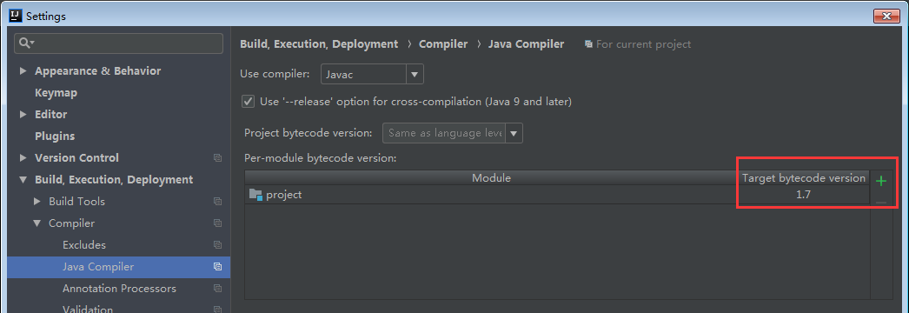

网上解释：maven的默认编译使用的jdk版本貌似很低，使用maven-compiler-plugin插件可以指定项目源码的jdk版本，编译后的jdk版本

## 更改IDEA项目版本

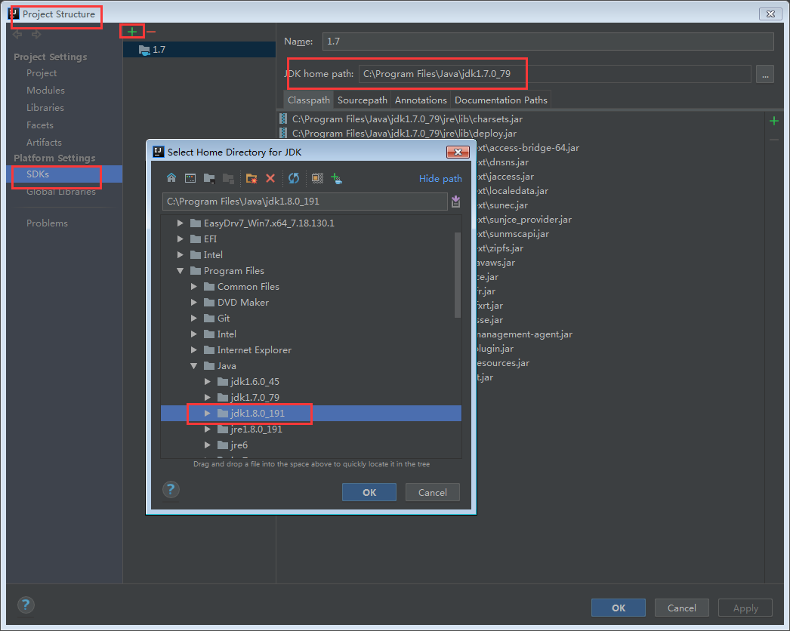

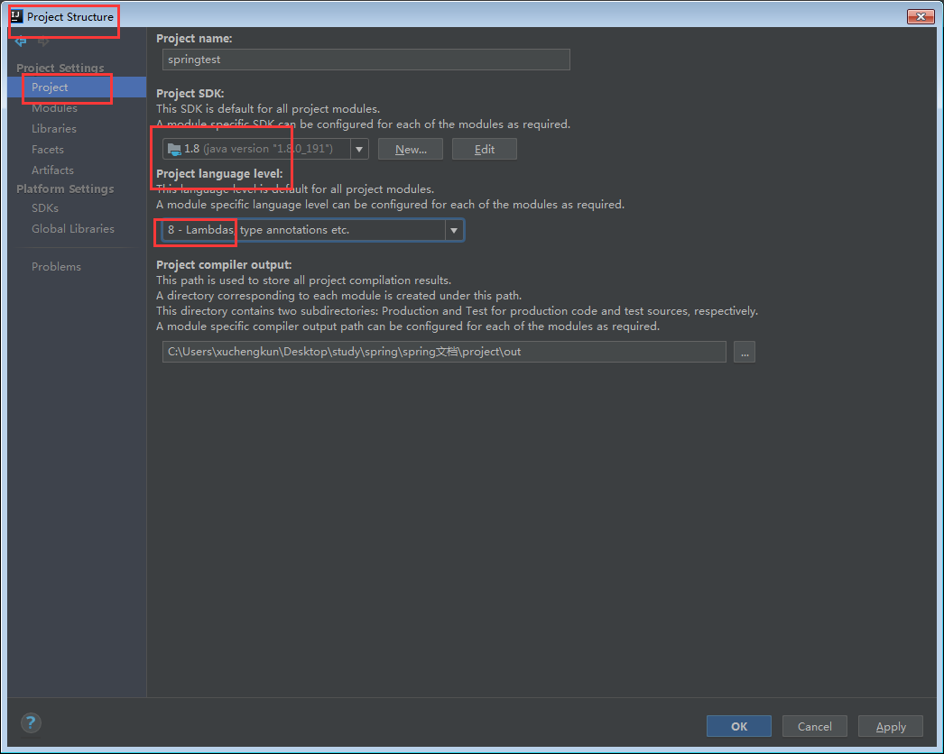

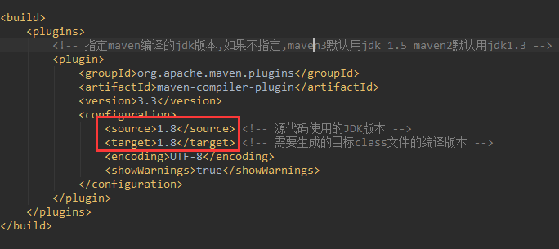

## Maven install无法从中央库中下载

最后才是重点，maven install的时候收到致命警告，协议版本的问题。

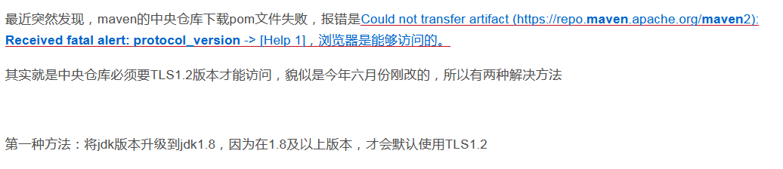

第二种：

maven的setting.xml设置为阿里云私服

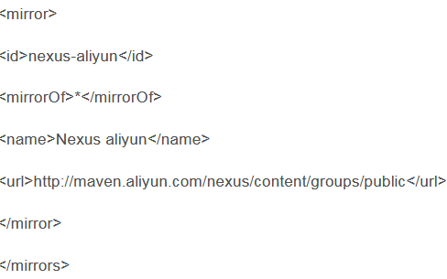

具体出错信息：

"C:\Program Files\Java\jdk1.7.0_79\bin\java.exe" -Dmaven.multiModuleProjectDirectory=C:\Users\xuchengkun\Desktop\study\spring\spring文档\project "-Dmaven.home=D:\xck\editor\IntelliJ IDEA 2018.1.5\plugins\maven\lib\maven3" "-Dclassworlds.conf=D:\xck\editor\IntelliJ IDEA 2018.1.5\plugins\maven\lib\maven3\bin\m2.conf" "-javaagent:D:\xck\editor\IntelliJ IDEA 2018.1.5\lib\idea_rt.jar=53628:D:\xck\editor\IntelliJ IDEA 2018.1.5\bin" -Dfile.encoding=UTF-8 -classpath "D:\xck\editor\IntelliJ IDEA 2018.1.5\plugins\maven\lib\maven3\boot\plexus-classworlds-2.5.2.jar" org.codehaus.classworlds.Launcher -Didea.version=2018.1.5 install -f pom.xml

[INFO] Scanning for projects...

[INFO]

[INFO] ------------------------------------------------------------------------

[INFO] Building springtest 1.0

[INFO] ------------------------------------------------------------------------

[INFO]

[INFO] --- maven-resources-plugin:2.6:resources (default-resources) @ springtest ---

[WARNING] Using platform encoding (UTF-8 actually) to copy filtered resources, i.e. build is platform dependent!

[INFO] Copying 3 resources

[INFO]

[INFO] --- maven-compiler-plugin:3.3:compile (default-compile) @ springtest ---

[INFO] Changes detected - recompiling the module!

[WARNING] File encoding has not been set, using platform encoding UTF-8, i.e. build is platform dependent!

[INFO] Compiling 4 source files to C:\Users\xuchengkun\Desktop\study\spring\spring文档\project\target\classes

[INFO]

[INFO] --- maven-resources-plugin:2.6:testResources (default-testResources) @ springtest ---

[WARNING] Using platform encoding (UTF-8 actually) to copy filtered resources, i.e. build is platform dependent!

[INFO] skip non existing resourceDirectory C:\Users\xuchengkun\Desktop\study\spring\spring文档\project\src\test\resources

[INFO]

[INFO] --- maven-compiler-plugin:3.3:testCompile (default-testCompile) @ springtest ---

[INFO] Changes detected - recompiling the module!

[WARNING] File encoding has not been set, using platform encoding UTF-8, i.e. build is platform dependent!

[INFO] Compiling 2 source files to C:\Users\xuchengkun\Desktop\study\spring\spring文档\project\target\test-classes

[INFO]

[INFO] --- maven-surefire-plugin:2.6:test (default-test) @ springtest ---

Downloading: https://repo.maven.apache.org/maven2/org/apache/maven/surefire/surefire-junit4/2.6/surefire-junit4-2.6.pom

[INFO] ------------------------------------------------------------------------

[INFO] BUILD FAILURE

[INFO] ------------------------------------------------------------------------

[INFO] Total time: 9.802 s

[INFO] Finished at: 2018-11-07T09:21:51+08:00

[INFO] Final Memory: 21M/179M

[INFO] ------------------------------------------------------------------------

[ERROR] Failed to execute goal org.apache.maven.plugins:maven-surefire-plugin:2.6:test (default-test) on project springtest: Error to resolving surefire provider dependency: Unable to get dependency information for org.apache.maven.surefire:surefire-junit4:jar:2.6: Failed to retrieve POM for org.apache.maven.surefire:surefire-junit4:jar:2.6: Could not transfer artifact org.apache.maven.surefire:surefire-junit4:pom:2.6 from/to central (https://repo.maven.apache.org/maven2): Received fatal alert: protocol_version

[ERROR] org.apache.maven.surefire:surefire-junit4:jar:2.6

[ERROR]

[ERROR] from the specified remote repositories:

[ERROR] central (https://repo.maven.apache.org/maven2, releases=true, snapshots=false)

[ERROR] Path to dependency:

[ERROR] 1) dummy:dummy:jar:1.0

[ERROR] -> [Help 1]

[ERROR]

[ERROR] To see the full stack trace of the errors, re-run Maven with the -e switch.

[ERROR] Re-run Maven using the -X switch to enable full debug logging.

[ERROR]

[ERROR] For more information about the errors and possible solutions, please read the following articles:

[ERROR] [Help 1] <http://cwiki.apache.org/confluence/display/MAVEN/MojoExecutionException>

## Maven install乱码

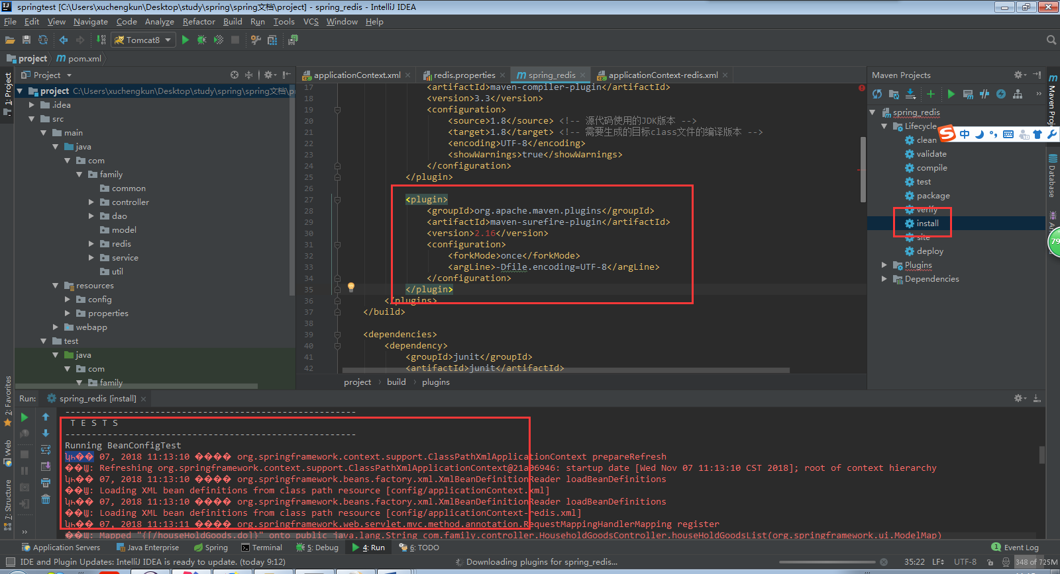

增加中间框住的插件maven-surefire-plugin，并配置编码-Dfile.encoding=UTF-8